**UNIT TESTING REPORTS**

1. **Testing of system”clear” function in main()**

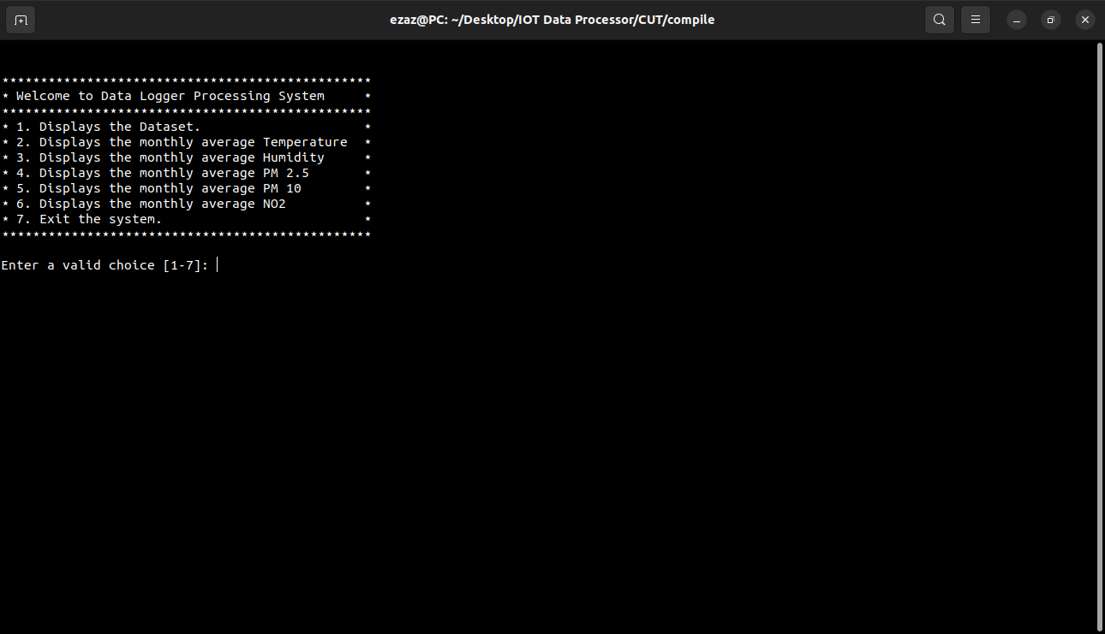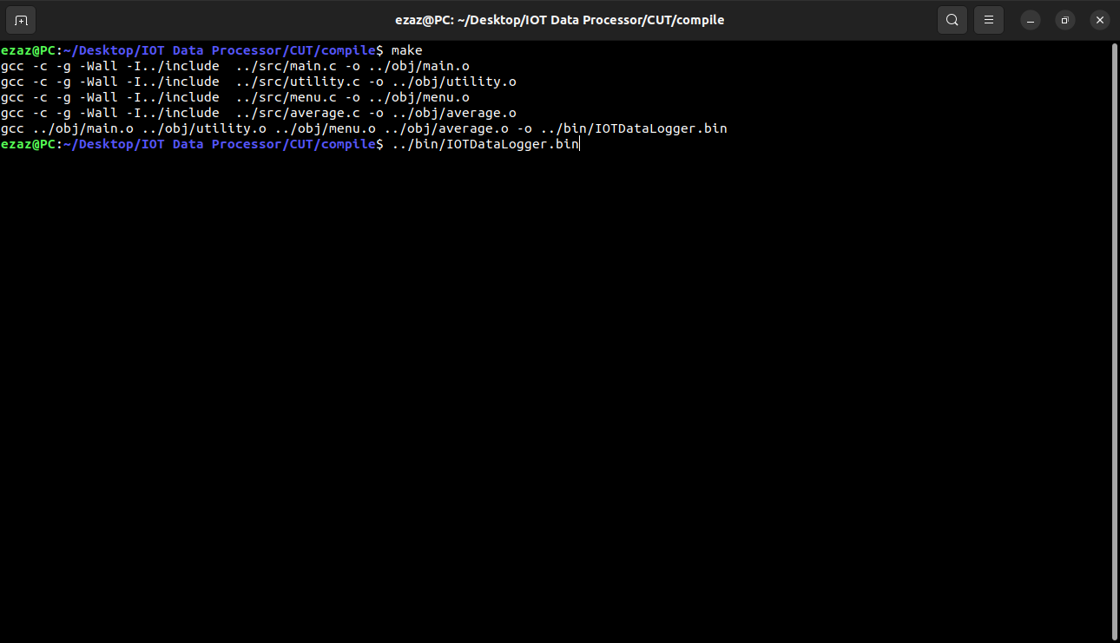

1. **Testing the non-numeric values of choice(ch) in menu()**

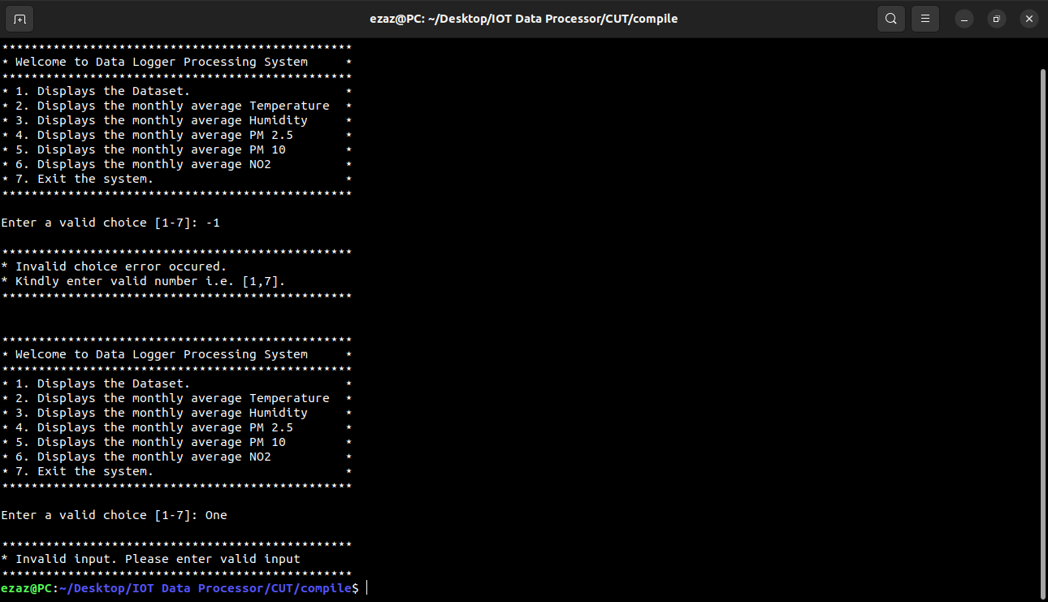

1. **Testing the negative values of choice(ch) in menu()**



1. **Testing the exit() in case 7 in menu()**

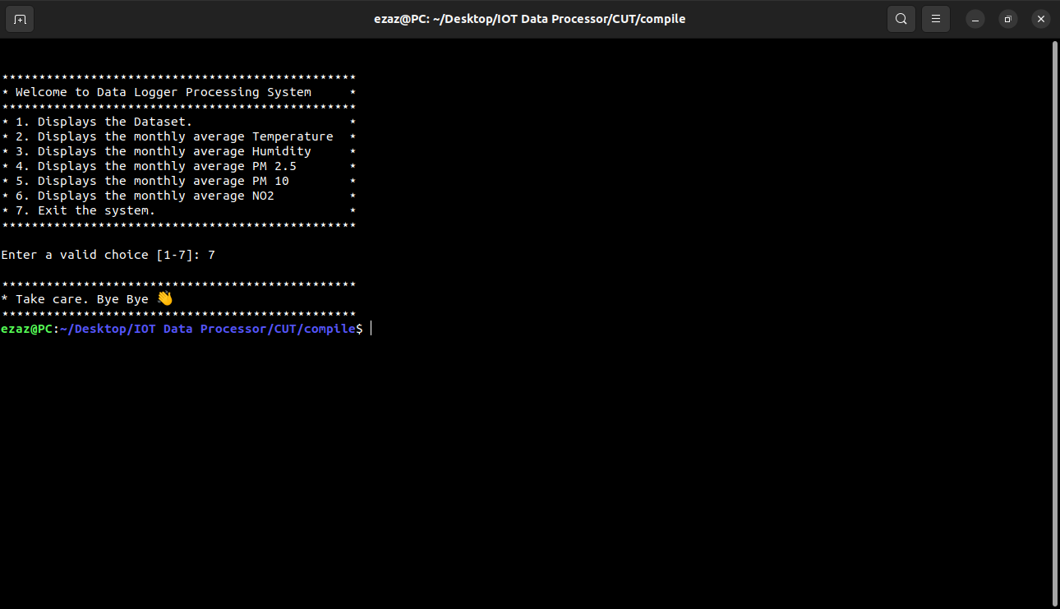

1. **Testing loadFromFile() in utility.c file**

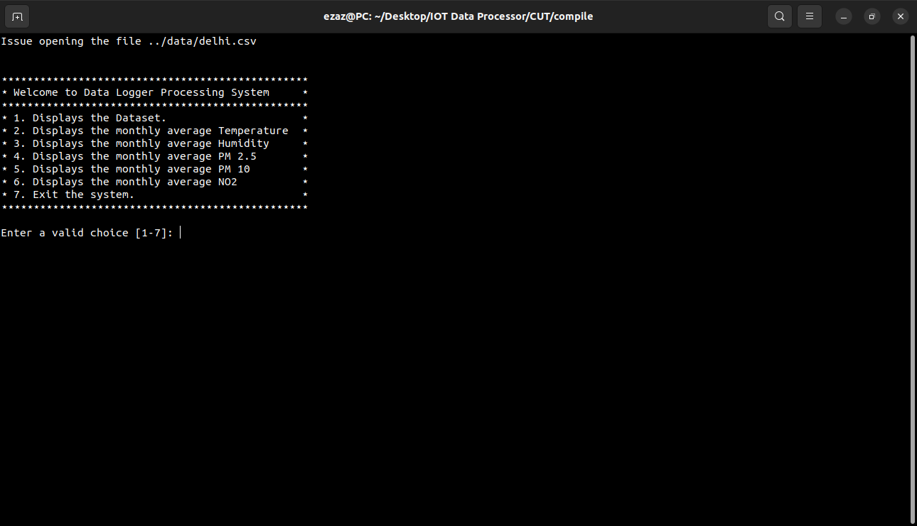

1. **Testing the count value of average.c file**

